**Assignment No.02**

**Name: -** Omprakash Khawshi

***************************************************************************

**Q.1 Use Random Function (( RANDOM )) to get Single Digit**

**RANDOM** is a shell variable that is used to generate random integers in Linux. It is an internal bash command that returns a pseudo-random 16-bit integer in the range 0 – 32767. It returns a different integer at each invocation.

**Code: -**

randomNumber=$(($RANDOM%3))

echo $randomNumber

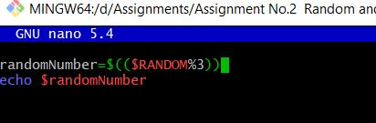

**Output: -**

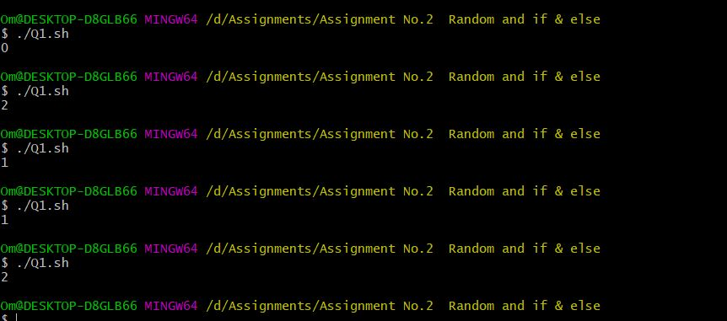

**Q.2 Use Random to get Dice Number between 1 to 6**

**Code: -**

randomNumber=$((1+$RANDOM%6))

echo $randomNumber

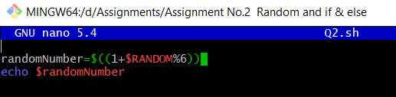

**Output: -**

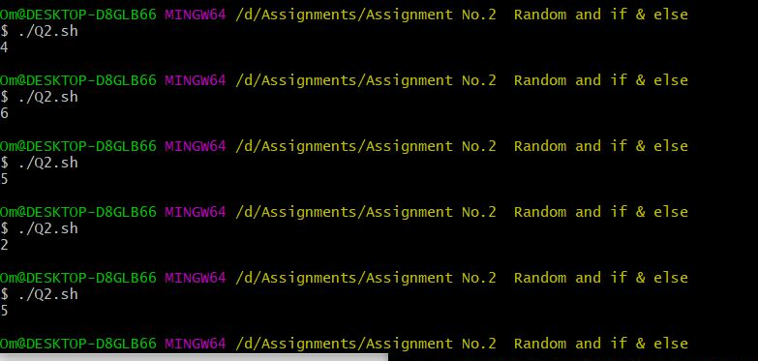

**Q.3 Add two Random Dice Number and Print the Result.**

**Code: -**

#! /bin/bash -x

Number_1=$((1+$RANDOM%6))

Number_2=$((1+$RANDOM%6))

Result=$(($Number_1+$Number_2))

echo $Result

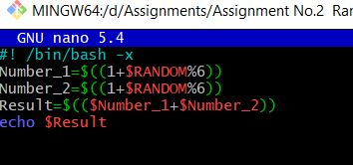

**Output: -**

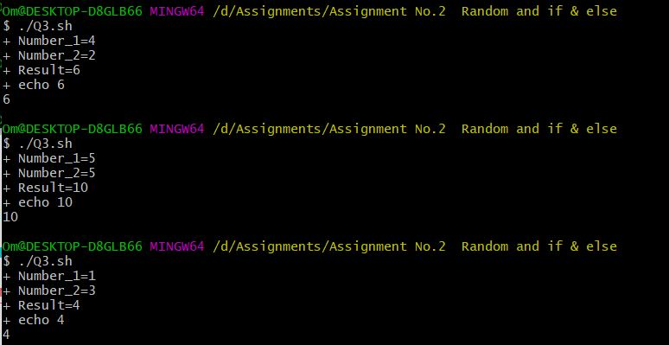

**Q.4 Write a program that reads 5 Random 2 Digit values , then find their sum and the average**

**Code: -**

Number_1=$((RANDOM%100))

Number_2=$((RANDOM%100))

Number_3=$((RANDOM%100))

Number_4=$((RANDOM%100))

Number_5=$((RANDOM%100))

Sum=$(($Number_1+$Number_2+$Number_3+$Number_4+$Number_5))

echo "Sum of 5 Numbers:-"$Sum

Average=$(($Sum/5))

echo "Average of 5 Numbers:-"$Average

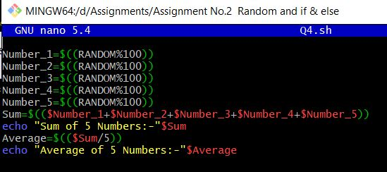

**Output: -**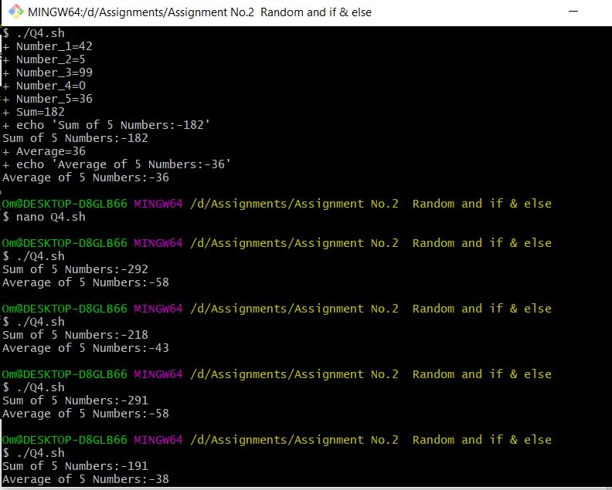

**Q.5 Unit Conversion**

**a. 1ft = 12 in then 42 in =? ft**

**b. Rectangular Plot of 60 feet x 40 feet in meters**

**c. Calculate area of 25 such plots in acre**

**Code: -**

echo -ne " 1.Inches to feets\n 2.Rectangular Plot of 60 feet x 40 feet in meters \n Enter Your Choice:- "

read Num

case $Num in

1)

echo " Enter the Inches:- "

read a

f2i=$(($a /12))

echo " Number of feet:- "$f2i

;;

2)

echo " Enter Rectangular Height :- "

read Height

echo " Enter Rectangular Width :- "

read Width

Rectangular_Area=$(expr $Width \* $Height)

echo " Area of rectangular :-"$Rectangular_Area

plot=$(($Rectangular_Area * 25))

#plot=$(echo "scale=3; $(($Rectangular_Area*25))")

echo " Area of 25 plots of dimension $Width Feet x $Height Feet is:-" $plot Feet

esac

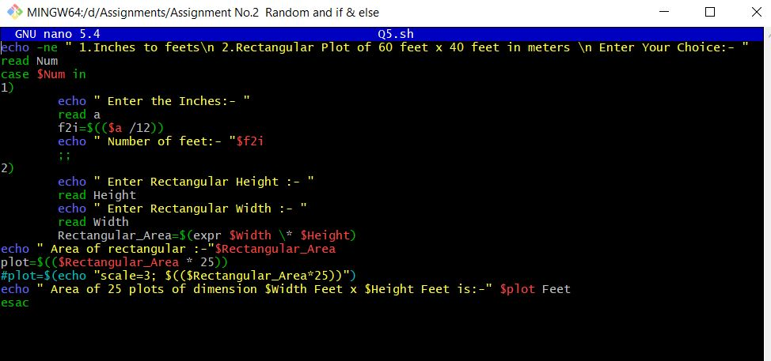

**Output: -**

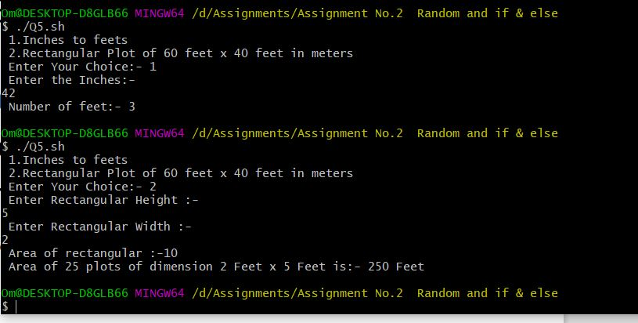

**If Else**

**Q.1 Write a program that reads 5 Random 3 Digit values and then outputs the minimum and the maximum value.**

**Code: -**

Maximum=0

Minimum=1000

for((i=1 ; $i<=5 ; i++))

do

n=$(($RANDOM%1000))

echo $n

if [[ $Maximum -lt $n ]]

then

Maximum=$(($n))

fi

if [[ $Minimum -gt $n ]]

then

Minimum=$(($n))

fi

done

echo "Maximum Value is:- " $Maximum

echo "Minimum Value is:- " $Minimum

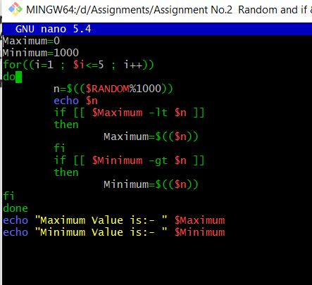

**Output: -**

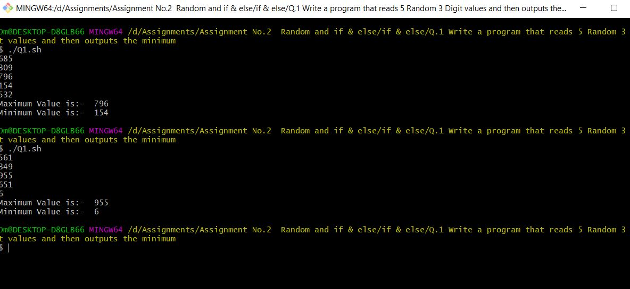

**Q.2 Write a program that takes day and month from the command line and prints true if day of month is between March 20 and June 20, false otherwise.**

**Code: -**

#!/bin/bash

read -p "Enter Date :-" Date

read -p "Emter Month :-" Month

if [[ $Month -eq "march" && $Date -gt 20 && $Date -lt 31 ]]

then echo "True"

elif [[ $Month -eq "april" && $Date -lt 30 ]]

then echo "True"

elif [[ $Month -eq "may" && $Date -lt 31 ]]

then echo "True"

elif [[ $Month -eq "june" && $Date -lt 20 ]]

then echo "True"

else

echo "False"

fi

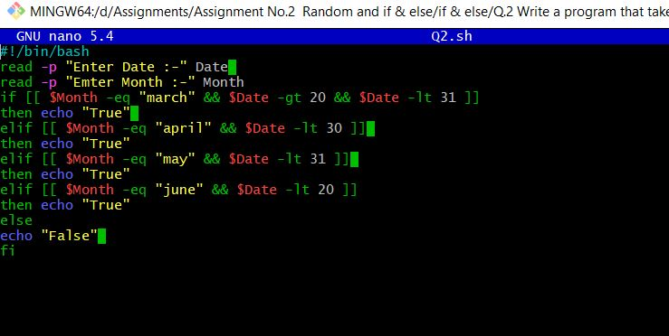

**Output: -**

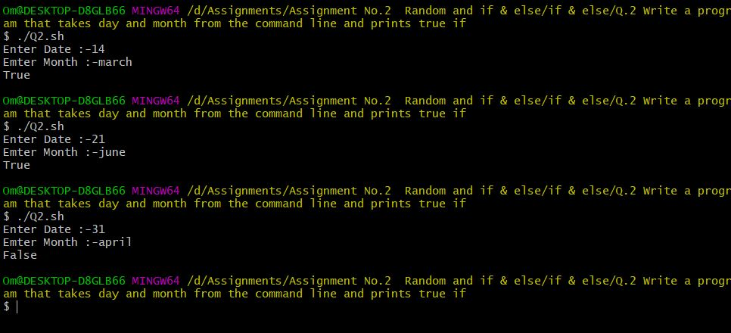

**Q.3 Write a program that takes a year as input and outputs the Year is a Leap Year or not a Leap Year. A Leap Year checks for 4 Digit Number, Divisible by 4 and not 100 unless divisible by 400.**

**Code: -**

#!/bin/bash

read -p "Enter a Year:-" Year

if [ $((Year % 4)) -eq 0 ]

then

if [ $((Year % 100)) -eq 0 ]

then

if [ $((Year % 400)) -eq 0 ]

then

echo "$Year is a leap year"

else

echo "$Year not a leap year "

fi

else

echo "$Year is Leap Year"

fi

else

echo "$Year Not a Leap Year"

fi

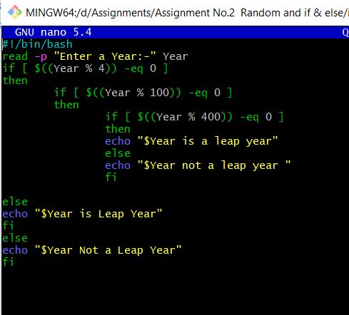

**Output: -**

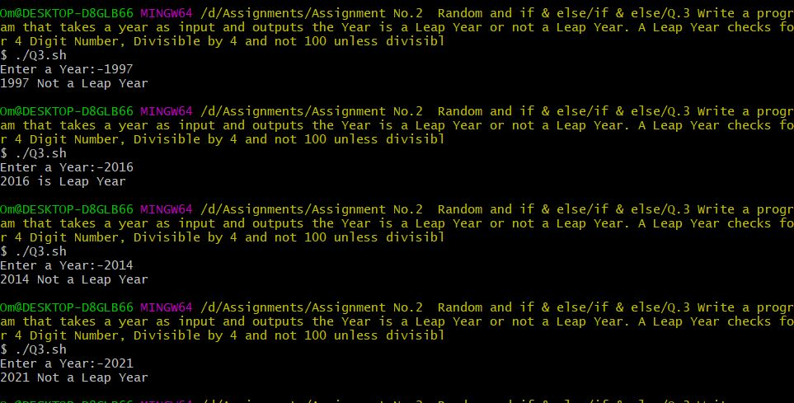

**Q.4 Write a program to simulate a coin flip and print out "Heads" or "Tails" accordingly.**

**Code: -**

#!/bin/bash -x

RandomNumber_1=$(expr $RANDOM % 10)

RandomNumber_2=$(expr $RANDOM % 2)

if [ $RandomNumber_2 -eq 0 ]

then

echo -ne "Head"

else

echo -ne "Tail"

fi

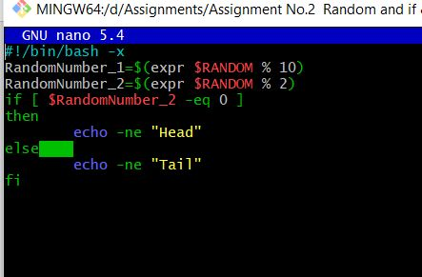

**Output: -**

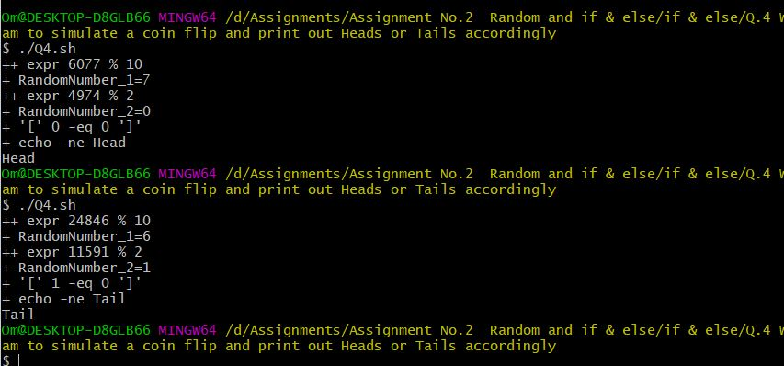

**if, elif and else**

**Q.1 Read a single digit number and write the number in word**

**Code: -**

read -p "Enter a Number between 1 to 9 :-" Number

if(($Number ==1))

then

echo "One";

elif(($Number ==2))

then

echo "$Number Two"

elif(($Number ==3))

then

echo "$Number Three"

elif(($Number ==4))

then

echo "$Number Four"

elif(($Number ==5))

then

echo "$Number Five"

elif(($Number ==6))

then

echo "$Number Six"

elif(($Number ==7))

then

echo "$Number Seven"

elif(($Number ==8))

then

echo "$Number Eight"

elif(($Number ==9))

then

echo "$Number Nine"

else

echo "Enter Number between 1 to 9 "

fi

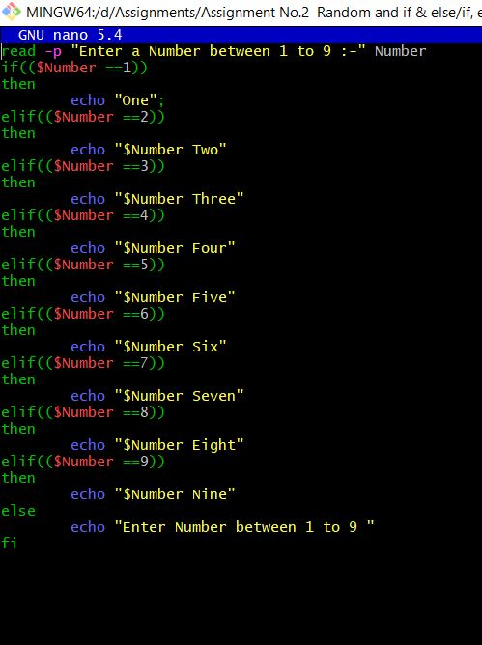

**Output: -**

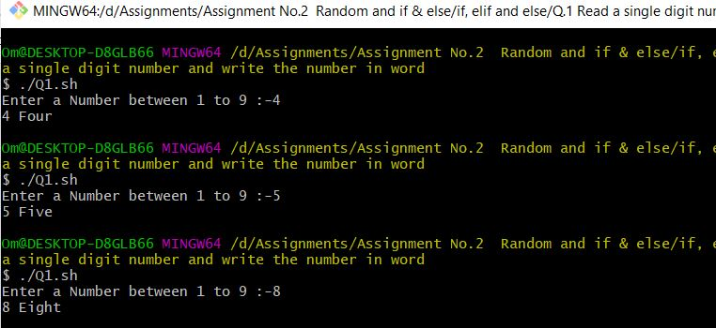

**Q.2 Read a Number and Display the week day (Sunday, Monday,…)**

**Code: -**

#!/bin/bash

read -p "Enter a Week Number :- " Number

if(($Number ==1))

then

echo "MONDAY";

elif(($Number ==2))

then

echo "TUESDAY"

elif(($Number ==3))

then

echo "WEDNESDAY"

elif(($Number ==4))

then

echo "THURSDAY"

elif(($Number ==5))

then

echo "FRIDAY"

elif(($Number ==6))

then

echo "SATURDAY"

elif(($Number ==7))

then

echo "SUNDAY"

else

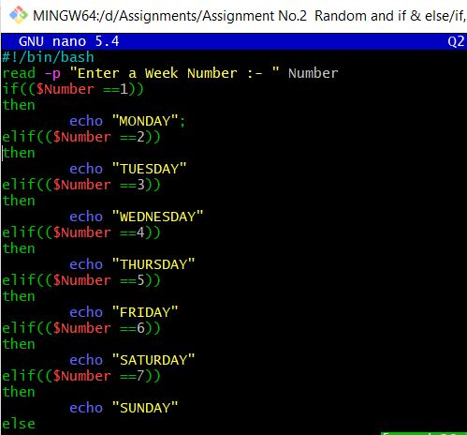

**Output: -**

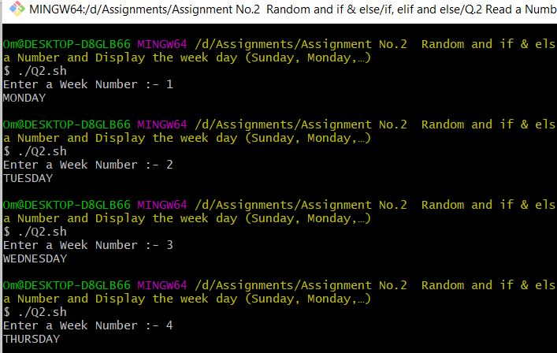

**Q.3 Read a Number 1, 10, 100, 1000, etc and display unit, ten, hundred,**

**Code: -**

echo -n "Enter the Number From 1, 10, 100, 1000 :- "

read n

if [ $n -eq 1 ]

then

echo -ne "UNIT \n"

else

if [ $n -eq 10 ]

then

echo -ne "TEN\n"

else

if [ $n -eq 100 ]

then

echo -ne "HUNDRED\n"

else

if [ $n -eq 1000 ]

then

echo -ne "THOUSAND \n"

else

echo -ne "You Enter Wrong Number "

fi

fi

fi

fi

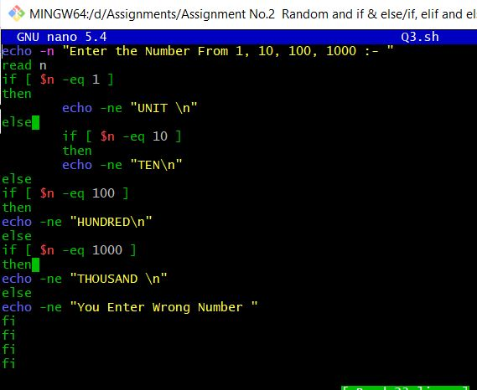

**Output: -**

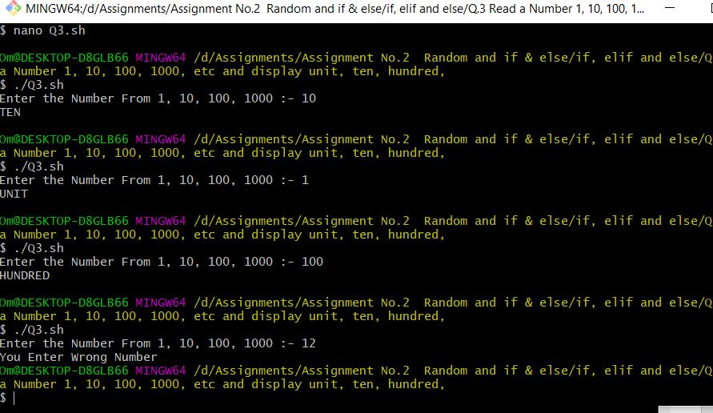

**Q.4 Enter 3 Numbers do following arithmetic operation and find the one that is maximum and minimum**

**1. a + b * c**

**2. a % b + c**

**3. c + a / b**

**4. a * b + c**

**Code: -**

read -p "Enter a First Number:- " a

read -p "Enter a Second Number:- " b

read -p "Enter a Third Number:- " c

A=$(( a + b * c ))

B=$(( a % b + c ))

C=$(( c + a / b ))

D=$(( a * b + c ))

echo $A

echo $B

echo $C

echo $D

if (($A>$B && $A>$C && $A>$D))

then

echo "$A is Maximum "

elif (($B>$A && $B>$C && $B>$D))

then

echo "$B is Maximum "

elif (($C>$A && $C>$B && $C>$D))

then

echo "$C is Maximum"

else

echo "$D is Maximum"

fi

if (($A<$B && $A<$C && $A<$D))

then

echo "$A is Minimum "

elif (($B<$A && $B<$C && $B<$D))

then

echo "$B is Minimum"

elif (($C<$A && $C<$B && $C<$D))

then

echo "$C is Minimum"

else

echo "$D is Minimum"

fi

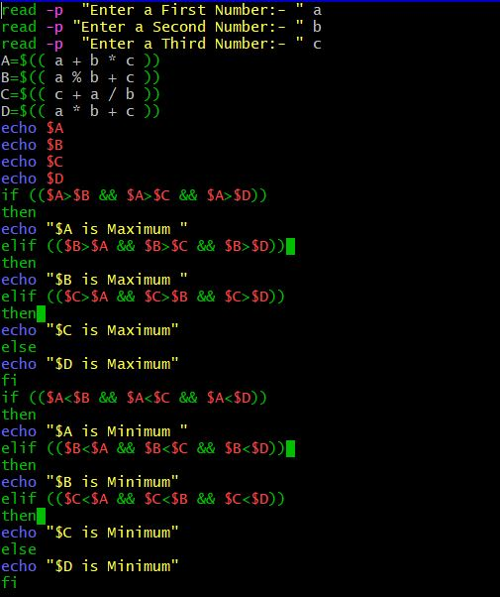

**Output: -**

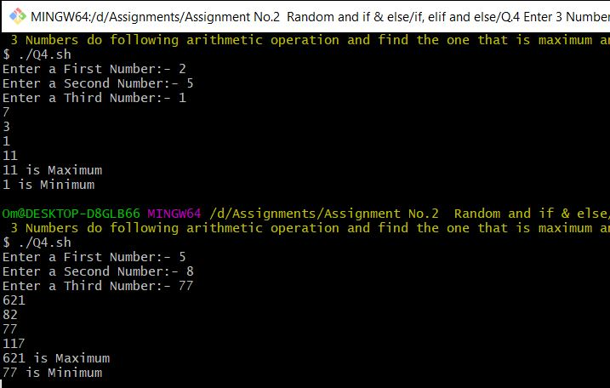

**case statement**

**Q.1 Read a single digit number and write the number in word using Case.**

**Code: -**

read -p "Enter Single Digit Number:- " number

case $number in

0)

echo "Zero"

;;

1)

echo "One"

;;

2)

echo "Two"

;;

3)

echo "Three"

;;

4)

echo "Four"

;;

5)

echo "Five"

;;

6)

echo "Six"

;;

7)

echo "Seven"

;;

8)

echo "Eight"

;;

9)

echo "Nine"

;;

esac

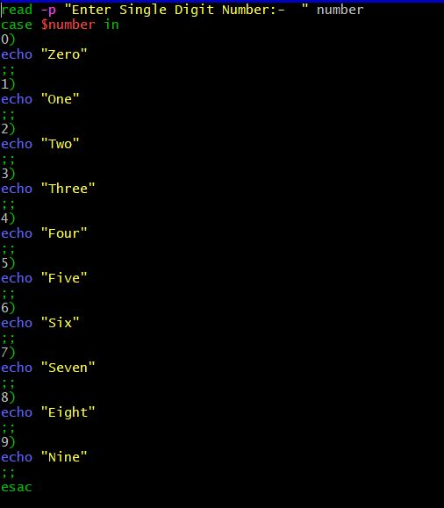

**Output:-**

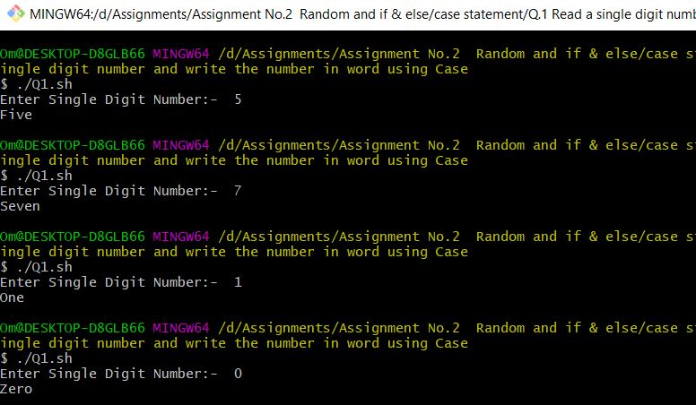

**Q.2 Read a Number and Display the week day (Sunday, Monday,….)**

**Code: -**

read -p "Enter Day Number:- " number

case $number in

1)

echo "Sunday"

;;

2)

echo "Monday"

;;

3)

echo "Thesday"

;;

4)

echo "Wenesday"

;;

5)

echo "Thursday"

;;

6)

echo "Friday"

;;

7)

echo "Saturday"

esac

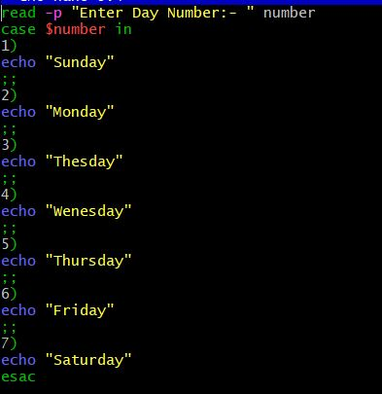

**Output: -**

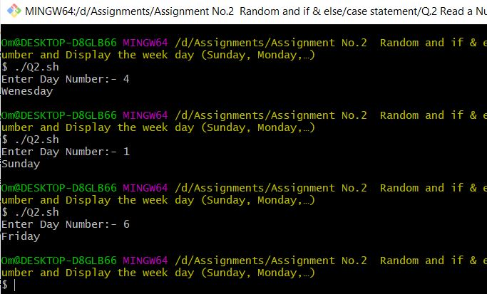

**Q.3 Read a Number 1, 10, 100, 1000, etc and display unit, ten, hundred,…**

**Code: -**

read -p "Enter Number from 1,10,100 and 1000:- " number

case $number in

1)

echo "Unit"

;;

10)

echo "Ten"

;;

100)

echo "Hundred"

;;

1000)

echo "Thousand"

;;

esac

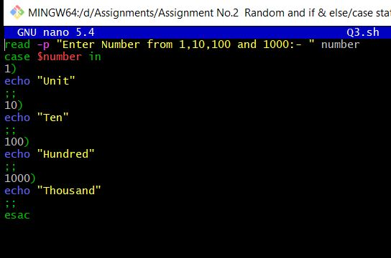

**Output: -**

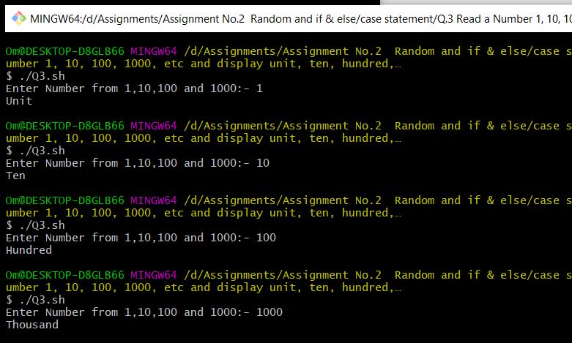

**Q.4 Write a program that takes User Inputs and does Unit Conversion of different Length units**

**1. Feet to Inch**

**2. Feet to Meter**

**3. Inch to Feet**

**4. Meter to Feet**

**Code: -**

echo -ne "1. Feet to Inch \n2. Inch to feet \n3. Feet Into Meter \n4. Meter into Feet \nEnter Your Choice :- "

read Number

case $Number in

1)

read -p "Enter Feets :- " Number

Inch=$(( $Number * 12 ))

echo "Number of Inches $Inch "

;;

2)

read -p "Enter Inches :- " Number

feet=$(( $Number / 12 ))

echo "Number of feets $feet"

;;

3)

read -p "Enter Feets :- " Number

meter=$(( $Number / 3 ))

echo "Number of Meter $meter "

;;

4)

read -p "Enter Meters :- " Number

feet=$(( $Number * 3 ))

echo "Number of Feets $feet "

;;

esac

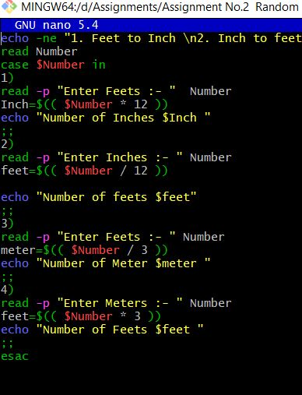

**Output: -**

